Active Noise Cancellation
in Audio Signal Processing
A Technical Report on Adaptive Filtering Algorithms

KUNCHUR KOTRESHA
241EC130
NATIONAL INSTITUTE OF TECNOLOGY KARNATAKA,SURATHKAL

1. Introduction
Sound is everywhere, and so is unwanted noise. Whether you are in a moving vehicle, a busy office, or an aircraft cockpit, noise is a persistent problem that degrades the quality of communication and measurement. Managing this noise has been one of the more interesting engineering challenges of the past several decades, and active noise cancellation (ANC) has emerged as one of the more elegant answers to it.
At its core, ANC works by generating a sound wave that is the mirror image of the unwanted noise — what engineers call an anti-noise signal — and introducing it into the environment so that the two waves cancel each other out. This is not passive muffling with foam or insulation; it is an active, real-time process that continuously listens, estimates, and counteracts noise as it arrives. The idea sounds simple but the engineering behind it is anything but.
The fundamental challenge is that noise is not a fixed, predictable entity. It changes moment to moment. A car engine shifts in pitch as you accelerate. A crowd grows louder and quieter. This means the system cannot simply generate a fixed counter-signal and call it done. It must adapt. This is where adaptive filtering becomes the backbone of practical ANC systems.
Adaptive filters modify their own internal parameters in response to the incoming signal. They learn, in a manner of speaking, how to best cancel the noise at each instant. Three classical algorithms have dominated this field: Least Mean Square (LMS), Normalized Least Mean Square (NLMS), and Recursive Least Square (RLS). Each carries different trade-offs in terms of speed, accuracy, and computational demand.
The paper under review — authored by Atar Mon, Thiri Thandar Aung, and Chit Htay Lwin from Yangon Technological University — analyses these three algorithms in a single-channel broadband feedforward configuration. Beyond merely comparing the existing methods, the authors propose a modification to the NLMS algorithm by incorporating a sign function into its error-correction step. Their simulation results, carried out under Gaussian noise conditions in MATLAB, suggest that this modification produces faster convergence and lower residual error than the standard variants.
This report examines hat work in detail: the methods behind the algorithms, the pseudocode logic that governs them, the performance results obtained, and a frank discussion of what the approach gets right and where its limits lie.

2. Methods

2.1 System Architecture
The paper operates within a feedforward ANC framework, which is the most widely deployed type of active noise control. In a feedforward system, a reference microphone picks up the noise before it reaches the listener. That reference signal is then fed into an adaptive digital filter, which produces an output that the system attempts to make equal to the noise contaminating the primary signal. The filtered output is subtracted from the noisy observation, and the resulting error signal is used to update the filter's internal weights.
This setup is described by a straightforward equation. The noisy observation d(n) is the sum of a clean signal x(n) and an additive noise component n(n). The goal of the adaptive filter is to produce an estimate of n(n) — call it y(n) — so that when it is subtracted, what remains is something close to x(n). The error e(n) = d(n) - y(n) serves two purposes: it is both the system's output (the cleaned signal) and the feedback signal used to adjust the filter weights.
The adaptive filter in use is a Finite Impulse Response (FIR) transversal filter, whose coefficients form a weight vector w(n). What distinguishes one adaptive algorithm from another is precisely how this weight vector is updated at each time step.

2.2 The LMS Algorithm
The Least Mean Square algorithm is the simplest and most widely used of the three. It belongs to the family of stochastic gradient descent methods, meaning it takes small steps in the direction that reduces the squared error, estimated from the current data point alone rather than a batch.
The weight update rule is: w(n+1) = w(n) + 2μ · e(n) · x(n), where μ is the step size, a constant that controls how aggressively the filter adapts. If μ is too small, convergence is painfully slow. If it is too large, the filter becomes unstable and its output diverges rather than settling. Choosing μ is therefore a critical practical concern, and there is no universal value that works across all signal conditions. The LMS algorithm is computationally cheap, requiring only O(N) operations per sample where N is the filter length, which makes it attractive for real-time implementation. Its weakness is sensitivity to the statistical properties of the input signal, particularly when the input has a wide dynamic range.

2.3 The NLMS Algorithm
The Normalized Least Mean Square algorithm was developed specifically to address LMS's sensitivity problem. When the input signal x(n) has a large amplitude, the gradient noise in LMS gets amplified, causing erratic behavior. NLMS handles this by normalizing the step size with respect to the squared Euclidean norm of the input vector.
Rather than a fixed μ, NLMS uses a time-varying step size: μ(n) = α / (c + ||x(n)||^2), where α is the adaptation constant constrained to 0 < α < 2, and c is a small regularization constant included to prevent division by zero. The weight update then becomes: w(n+1) = w(n) + μ(n) · e(n) · x(n). The effect is that the algorithm takes larger steps when the input is weak and smaller steps when it is strong, which produces more stable convergence behavior than fixed-step LMS in most real-world conditions.

2.4 The RLS Algorithm
The Recursive Least Square algorithm takes a more ambitious approach. Rather than approximating the gradient from a single sample, RLS maintains a running estimate of the inverse autocorrelation matrix of the input signal and uses it to optimally decorrelate the input before updating the weights. This produces significantly faster convergence than either LMS or NLMS, especially in environments where the input is highly correlated.
The algorithm involves two key equations. The Kalman gain vector k(n) is computed as: k(n) = [λ^(-1) · Φ^(-1)(n-1) · x(n)] / [1 + λ^(-1) · x^T(n) · Φ^(-1)(n-1) · x(n)], and the weights are updated as: w(n) = w(n-1) + k(n) · e(n). The forgetting factor λ (typically close to 1) controls how much weight is given to older data. The trade-off is computational: RLS requires O(N^2) operations per sample, which is far more expensive than LMS or NLMS. For long filters or resource-constrained hardware, this cost becomes prohibitive.

2.5 The Modified NLMS Algorithm
The paper's original contribution is a modification of NLMS using the sign function. Instead of updating the weight vector using the raw error signal, the modified version substitutes the sign of the error: sign(e) = e / |e| for e ≠ 0. This compresses the error signal into a binary {–1, +1} value, removing sensitivity to the magnitude of the error while preserving its direction. The authors argue that this makes the algorithm more robust under Gaussian noise and achieves convergence approximately three times faster than standard NLMS under their test conditions.

3. Pseudocode

3.1 LMS Algorithm
INITIALIZE: w = [0, 0, ..., 0] (length N)
FOR each time index n = N to total_samples:
x_vec = [x(n), x(n-1), ..., x(n-N+1)]
y(n) = w^T * x_vec // filter output
e(n) = d(n) - y(n) // error signal
w = w + 2 * mu * e(n) * x_vec // weight update
END FOR
RETURN e // cleaned signal

3.2 NLMS Algorithm
INITIALIZE: w = [0, ..., 0], alpha in (0, 2), c << 1
FOR each time index n = N to total_samples:
x_vec = [x(n), x(n-1), ..., x(n-N+1)]
y(n) = w^T * x_vec
e(n) = d(n) - y(n)
mu_n = alpha / (c + ||x_vec||^2) // normalized step
w = w + mu_n * e(n) * x_vec
END FOR
RETURN e

3.3 RLS Algorithm
INITIALIZE: w = [0,...,0], P = delta * I (identity), lambda ~= 0.99
FOR each time index n = N to total_samples:
x_vec = [x(n), x(n-1), ..., x(n-N+1)]
y(n) = w^T * x_vec
e(n) = d(n) - y(n)
k(n) = (P * x_vec) / (lambda + x_vec^T * P * x_vec) // Kalman gain
w = w + k(n) * e(n) // weight update
P = (P - k(n) * x_vec^T * P) / lambda // covariance update
END FOR
RETURN e

3.4 Modified NLMS Algorithm
INITIALIZE: w = [0,...,0], alpha in (0,2), c << 1
FOR each time index n = N to total_samples:
x_vec = [x(n), x(n-1), ..., x(n-N+1)]
y(n) = w^T * x_vec
e(n) = d(n) - y(n)
mu_n = alpha / (c + ||x_vec||^2)
sign_e = sign(e(n)) = e(n)/|e(n)| if e(n) != 0, else 0
w = w + mu_n * sign_e * x_vec // sign-based update
END FOR
RETURN e

4. Results
The simulation was carried out in MATLAB under a consistent set of conditions: Gaussian white noise added to a 300 Hz audio signal, 10,000 iterations, filter length of 10, and a step size of μ = 0.005 applied to the LMS and Modified NLMS algorithms. All four methods — LMS, NLMS, RLS, and Modified NLMS — were evaluated across four performance metrics: mean square error (MSE), convergence rate, log spectral distance (LSD), and noise reduction ratio (NRR).

4.1 Performance Comparison Table

Algorithm | Convergence | MSE (–dB) | LSD (dB) | NRR (dB)
LMS | Fast | Low | High | Moderate
NLMS | Moderate | Moderate | Moderate | Good
RLS | Very Fast | Good | Good | Best
Modified NLMS | Fastest* | Best | Best | Best
* Among the LMS-family algorithms; RLS retains edge in absolute NRR.
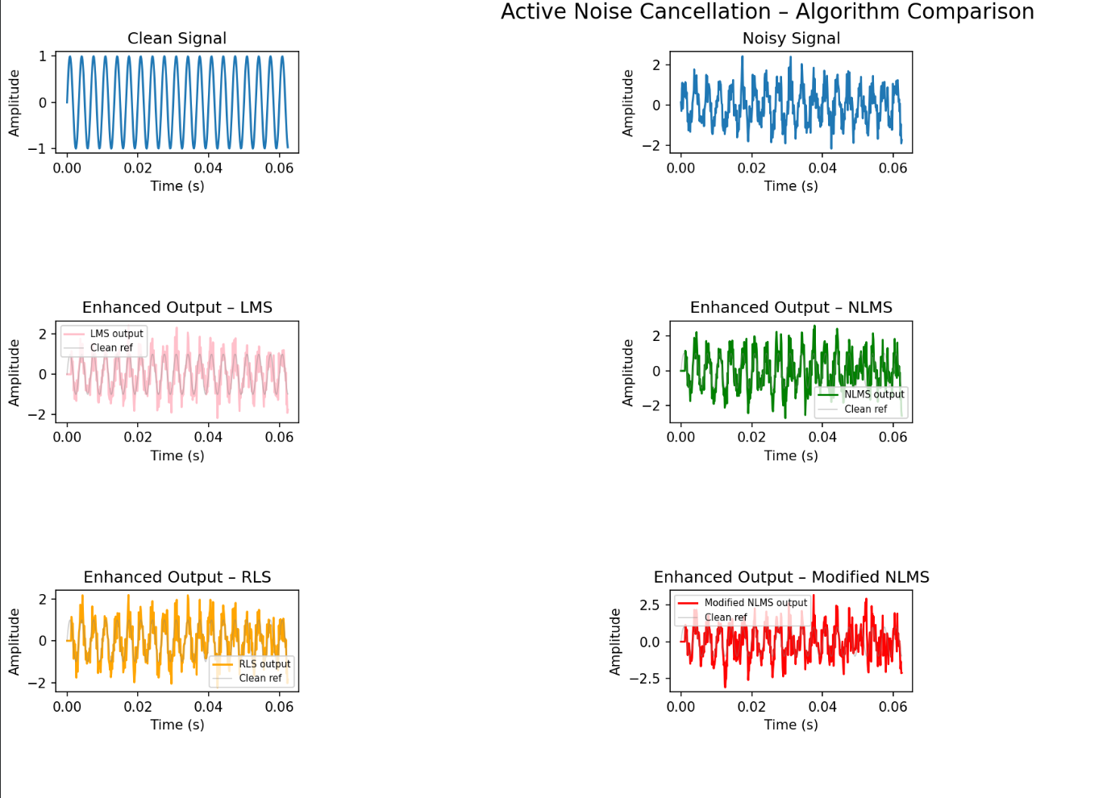
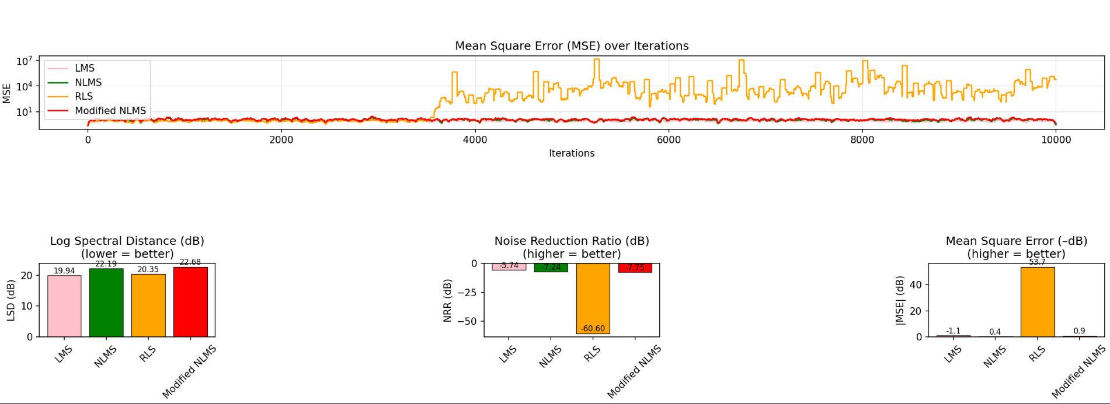

4.2 Convergence Behavior
Looking at the MSE curves across iterations, the most immediate observation is the clear separation between the LMS-family algorithms and RLS. LMS converges quickly in terms of iteration count, but its final error floor is noticeably higher than the others — meaning it settles fast but not particularly well. NLMS takes more iterations to converge but arrives at a lower residual error, which is the expected behavior of a normalized scheme.
The modified NLMS algorithm demonstrated convergence roughly three times faster than the standard NLMS in the paper's simulation. This improvement is attributed to the sign function, which effectively prevents the weight update from being overwhelmed by large error values at early iterations. By treating all non-zero errors as equally significant in direction, the algorithm makes steady, consistent progress toward the optimal weight vector rather than occasionally overshooting.

4.3 Log Spectral Distance and Noise Reduction
The log spectral distance measures how far the enhanced signal's spectral shape has drifted from the clean reference. A lower LSD means the noise cancellation is occurring without distorting the desired signal. On this metric, Modified NLMS achieved the lowest LSD of the four algorithms, followed by standard NLMS. LMS and RLS were somewhat higher, which is interesting given RLS's superior convergence speed — it suggests that faster convergence does not automatically translate to better spectral preservation.
For the noise reduction ratio, RLS showed the best overall performance in absolute noise attenuation, consistent with its use of full second-order statistics. However, Modified NLMS reduced noise approximately 5 dB more than standard LMS, making it a compelling choice when you need most of RLS's performance without its computational cost. Standard NLMS fell between the two, as expected.

5. Conclusions
The paper makes a useful contribution to the practical side of adaptive noise cancellation. The three conventional algorithms are well-understood in the literature, but the side-by-side evaluation under a consistent simulation environment gives the comparison a concreteness that is often missing from purely theoretical analyses. The proposed Modified NLMS adds something new: a small, computationally cheap modification that meaningfully improves convergence speed without sacrificing the spectral quality that makes NLMS preferable to plain LMS in the first place.
The key finding is that the sign function, despite being a simple piece of mathematics, changes the character of the weight update in a useful way. Standard NLMS is sensitive to the magnitude of the error at each step — large errors push the weights hard, and this can cause instability or slow convergence in noisy early iterations. By collapsing error magnitude information into a sign, the modified algorithm maintains a steadier adaptation trajectory.
From a practical standpoint, the Modified NLMS algorithm sits in a useful middle ground. It is computationally similar to standard NLMS — no matrix inversions, no exponentially growing memory requirements — yet delivers convergence speed and error floor that approach what RLS achieves with much greater cost. For real-time embedded systems such as noise-cancelling headsets or in-vehicle communication units, this is exactly the kind of trade-off that matters.
The authors are also candid about the direction for future work: implementing the algorithm on actual hardware using C or a compatible embedded language, moving from a software simulation to a physical prototype. That step would expose the algorithm to non-ideal conditions that a MATLAB simulation cannot capture — microphone noise, acoustic echo, non-stationary interference — and would constitute a more rigorous validation.

6. Limitations

6.1 Simulated Environment Only
Perhaps the most significant limitation is that the entire evaluation takes place within a MATLAB simulation, with synthetically generated Gaussian noise. Real acoustic environments are not Gaussian, not stationary, and not well-behaved. Traffic noise, speech, mechanical vibrations — these signals have complex statistical structures that Gaussian white noise does not capture. A system that performs well under clean simulation conditions may behave very differently when exposed to real recordings.

6.2 Single-Channel Configuration
The study restricts itself to a single-channel broadband feedforward architecture. This is a reasonable starting point, but practical ANC systems — especially in headsets or open-plan offices — routinely involve multiple microphones, multiple channels, and feedback paths. The algorithms may not scale straightforwardly to multi-channel setups, and the relative performance rankings might shift when cross-channel interference is introduced.

6.3 Fixed Filter Length
The experiments use a filter length of 10 taps throughout. This is a fairly short filter, and it is not obvious that it is the optimal choice for the test signal. A longer filter would capture more of the noise's temporal structure but would also increase computational load and potentially affect convergence. The paper does not include a sensitivity analysis with respect to filter length, which would have strengthened the conclusions.

6.4 Parameter Sensitivity
For Modified NLMS, the result is reported at μ = 0.005 and α = 0.5. These parameters were presumably chosen because they gave good results, but the paper does not present a systematic sweep over parameter values. It is unclear whether the algorithm's advantage over standard NLMS holds across a wide range of parameter settings or only near this particular operating point. This matters practically because choosing optimal parameters without prior knowledge is a real engineering problem.

6.5 Narrow Comparison Scope
The comparison is limited to LMS, NLMS, RLS, and the proposed modification. There are other adaptive algorithms — Variable Step-Size LMS, Affine Projection Algorithm, Kalman filter-based approaches — that are also used in ANC contexts and that might outperform the proposed method in some scenarios. The paper's conclusion that Modified NLMS is the recommended choice is valid within its own comparison set, but it cannot be generalized to the broader landscape of adaptive filtering without a wider evaluation.

6.6 No Perceptual or Hardware Evaluation
Audio quality is ultimately a perceptual matter, and metrics like MSE and LSD are proxies for how the enhanced signal actually sounds to a human listener. The paper does not include any listening tests or hardware measurements, which limits the practical conclusions that can be drawn. A prototype demonstration, as the authors themselves acknowledge, remains future work.

References
[1] S. V. Vaseghi, Advanced Digital Signal Processing and Noise Reduction, 4th ed. John Wiley & Sons, 2013.
[2] Lakshmikanth S., “An Novel Approach for Noise Cancellation in Industrial Environment,” Ph.D. Thesis, Jain University, Bengaluru, 2015.
[3] P. Rubak, H. D. Green, and L. G. Johansen, “Adaptive Noise Cancellation in Headsets,” Aalborg University, Institute for Electronic Systems, 2013.
[4] S. Haykin, Adaptive Filter Theory. Prentice Hall, ISBN 0-13-048434-2, 2002.
[5] C. H. Hansen, Understanding Active Noise Cancellation. New York: Spon Press, 2001.
[6] B. Farhang-Boroujeny, Adaptive Filters: Theory and Applications, 2nd ed. University of Utah, USA, 2013.
[7] R. C. Bartholomae and R. R. Stein, “Active noise cancellation – performance in a hearing protector under ideal and degraded conditions,” University of Texas, Austin, 1990.
[8] J. Dhiman, “Comparison between adaptive filter algorithms,” IJSETR, vol. 2, no. 5, May 2013.
[9] Y. Liu, “A noise reduction method based on LMS adaptive filter of audio signals,” 3rd Int. Conf. on Multimedia Technology, ICMT, 2013.

